**Volume Web store Design Document**

https://www.bene.be/blog/comments/a_webdesign_brief_document_for_every_website

**Introduction**

This document will outline our design for the Volume-inc Webpage, we will talk about our goals for the website as well as the overall design of the site.

**Project Milestones**

There are a few different milestones along the course of building the site, the first one will be the completion of the front page. This will lay the ground work for every other page as we will be using elements such as the nav bar throughout all the pages of the website.

Once we have completed the front page we will have the basics for the rest of the pages, however another milestone at this point will be the database. Once the database is finished and populated we will be able to start putting items onto the store pages.

Now that the database and front page is done we will be moving onto the rest of the pages the next milestone is the men’s and women’s pages for the website. Now that we have the database linked with the website we can start displaying and selling our products the selling part will be the next milestone. But for this milestone the men’s and women’s pages are to be done.

The next milestone is setting up the payment gateway for the products we will be selling. This will be linking the database with our website but also linking it with PayPal so that customers can go onto the page and buy products we are offering. We will have to set up a business account to take in purchases.

The next milestone is setting up the help page which will be where customers can send us emails on problems they might encounter. It will need to be coded so that we receive the emails from customers and a valid email address is entered.

The last milestone will be the testing of the website and this will be black box testing and this will give the website a robust test of every usability that the user will encounter with the website this will show us if there are any problems the goal for the end of this for the website to withstand the testing and be a fully operating website with no errors.

**Target Audience**

The target audience for the site would be similar to ourselves, 18-30 men and women who generally shop at places like END, Size or JD. They are generally looking to spend £20 - £40 for t-shirts on these websites. They also like inflated images of products and if popular products are shown on the home page they are more inclined to buy. Before we started working on the website we researched the audience we would be attracting and the websites they were constantly looking at and looked at all of the layouts, buttons they used etc and gathered enough information to product our design document.

**Design**

**Colours**

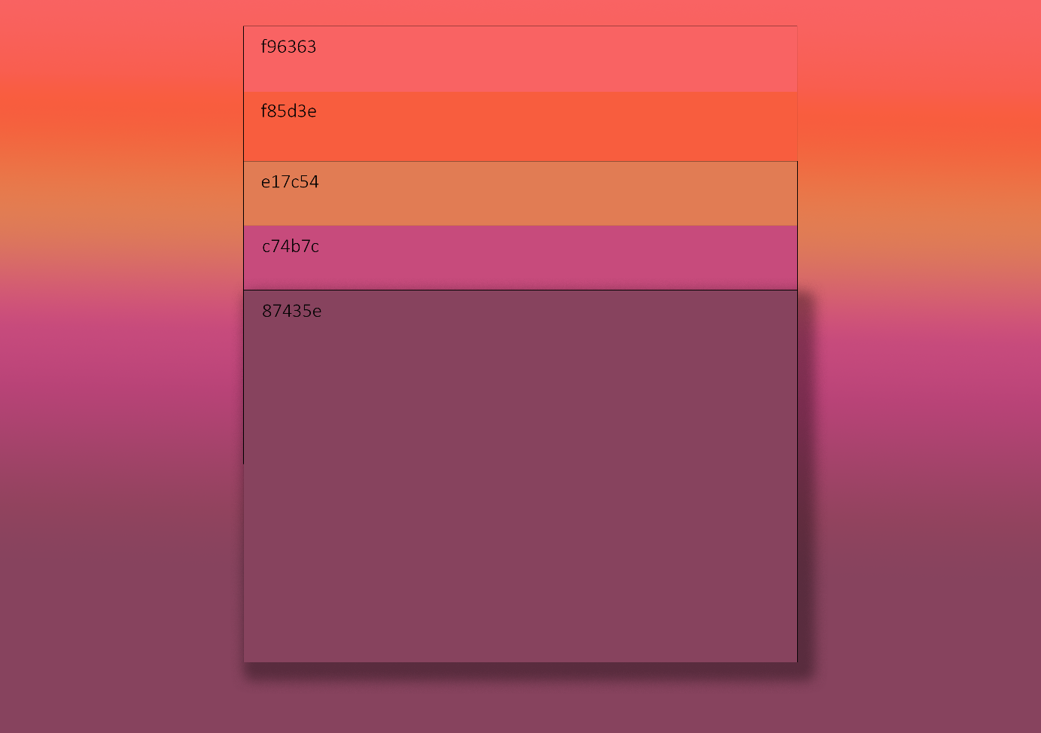

The colour palet for our website is a mixture of pastel colours. These are going be the main colours we use for our website.

**Logo**



Logo was created by Aows to be simple as we are trying to emulate the minimalist style that is currently very popular with the demographic we are aiming at. This will be the image that the users will associate with our website the most so it has to be good and stand out.

**Font**

The font we will be using for the website is the one that is used when using bootstrap. We have done this because bootstrap gives you a font and size to use depending on which heading tags you use. The fonts also differ from which broswer the user is in so that it does automatically rather than Aows and Jordan having to do it by themselves. <https://getbootstrap.com/docs/4.0/content/reboot/#native-font-stack> this is the bootstrap website that describes all of the fonts and headings.

**Lay-out**

**State diagram**

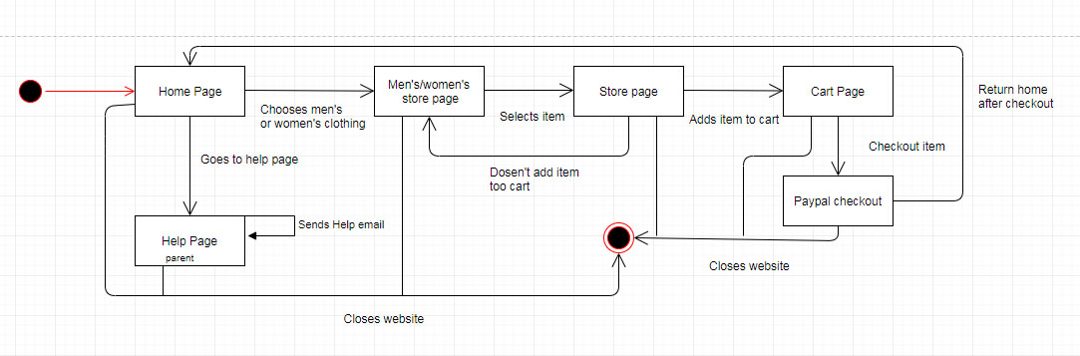

This is the state diagram for the our website. This is a visual representation of the behaviour of our website. This is also a representation of how we expect the users to navigate through the website. We have it starting of on the home page then advancing through the website with all possibilities including the end product of closing of the site.

**Front Page**

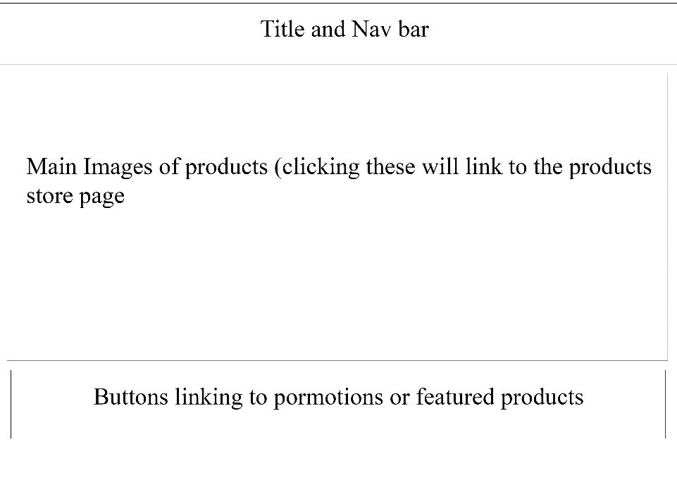

This is the design for the front page of the site at the top we have the nav bar which will be on all of the pages so the user can navigate through the website. Then we have the products which we will be showing in the body. Then in the footer we will be having buttons and images linking to promotions or popular products.

**Mobile Front page**

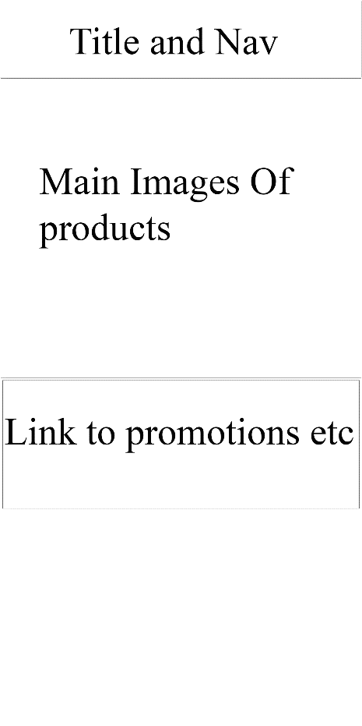

The mobile front page is just a condensed version of the desktop page just that it does not have the hover and for the nav it is a drop down menu which you have to tap to get it down. The lay-out for the other pages are the same just condensed and with the drop down touch menu.

**Store Page**

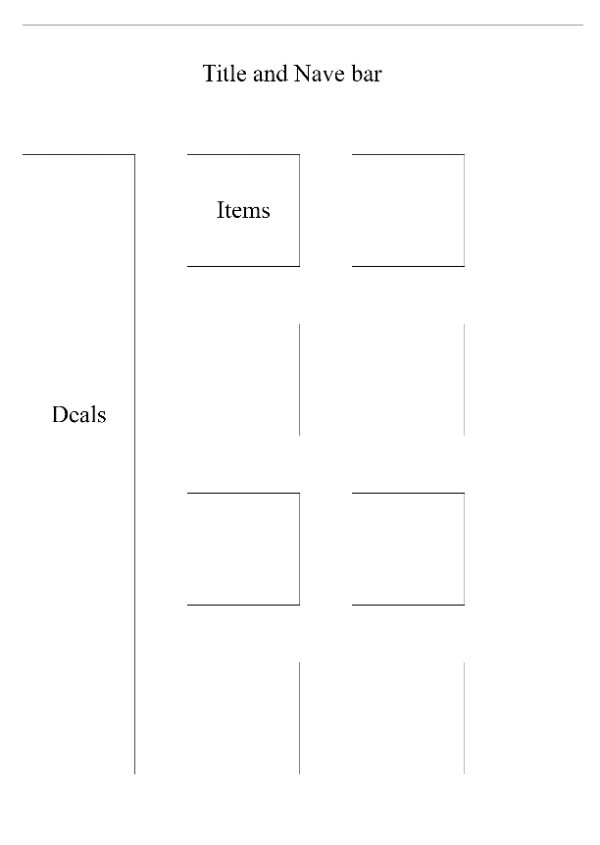

This is the store page that we will be using for the men’s and women’s pages. At the top we have the nav bar which is universal for the site then down the left we have deals we will be promoting then in the middle it is all of the products we will be selling which will take you to the product pages.

**Cart page**

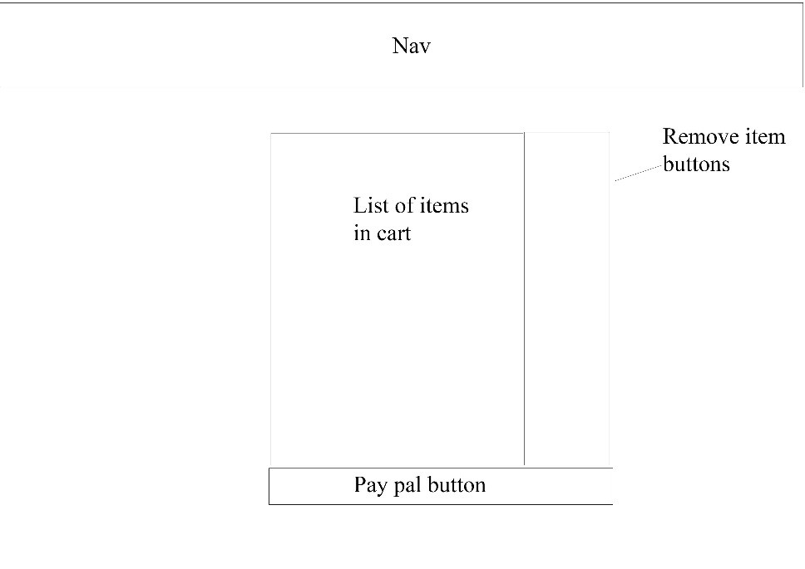

The cart page has the item you have selected then the PayPal button below it to take you to PayPal to pay for one of our products. Then we also have the remove item button at the side to take stuff out of cart.

**Product page**

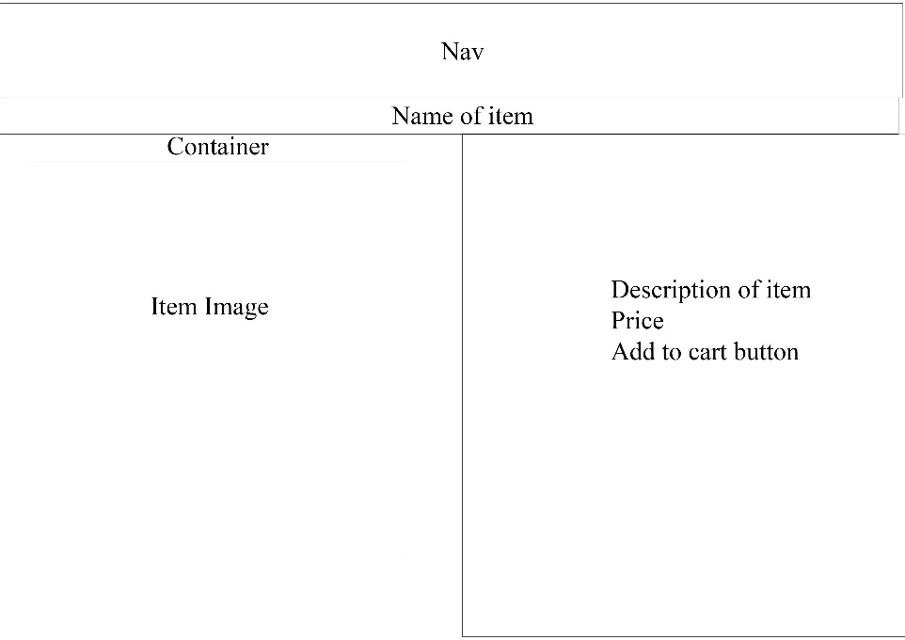

The product page has the nav as usual then it has the container for the item image then to the right of that it has the description of the item then price then the add to cart button.

These are the basic layouts we will be using for our divs for the various pages, these layouts are taken from our research of other websites we are trying to emulate. We looked at many different layouts similar sites to us are using and we got these ideas we have chosen these because they are very easy to navigate for our users and easy to navigate throughout the sites and get to certain places of the site and also we have chosen these because it is easy for the user to get to certain products of the page and easy to pay for items etc.

**Interactive elements**

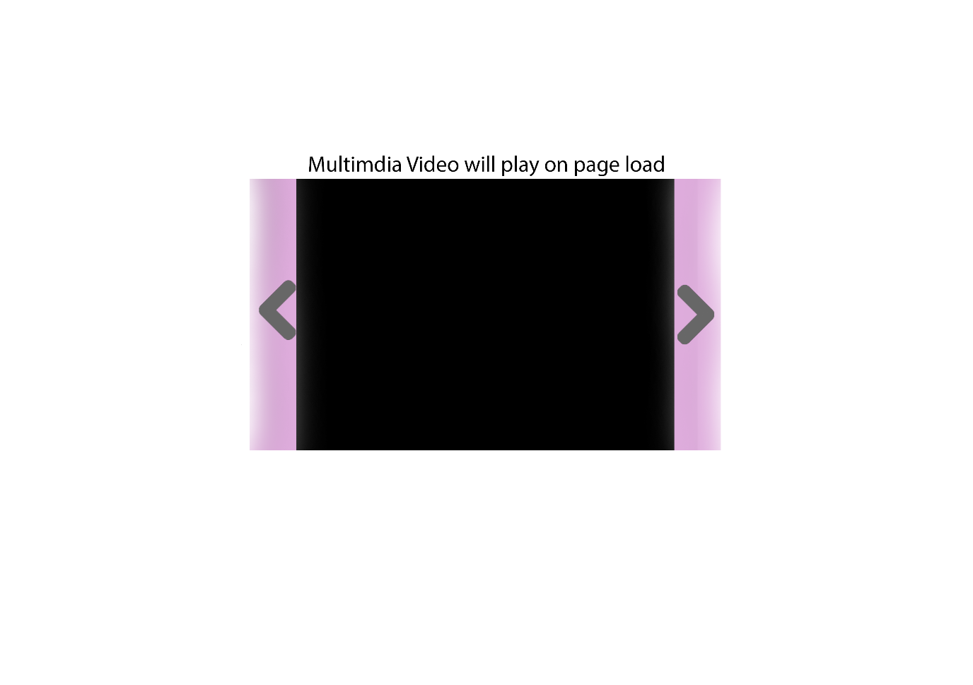

The first slide of the slideshow will be a custom made video, this will add some extra quality to the website making it much more appealing and professional looking. We want the user to see our website and think that it looks well-made therefor the products we are selling must also be high quality.

Additionally we think it will engage users more than just a static image and make the site stick in their mind more making them more likely to return to the site in the future.

We will have to keep in mind that a HD video may not be suitable for a mobile site because of data usage problems. To tackle this we will keep the video limited to desktop and tablet versions of the site and use a static image for the mobile site in order to better optimize for those users.

**Example Sites**

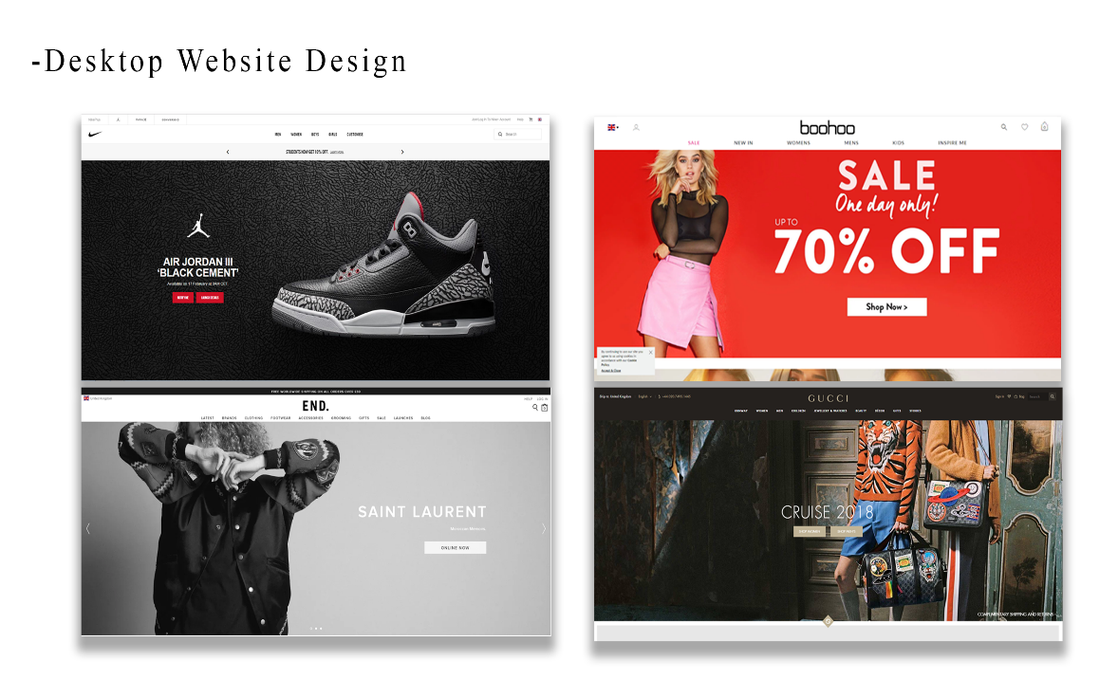

Above are examples of sites we are going to try and emulate, there are a few common themes from these sites that we have tried to incorprate into our design. The main viewport is taken up by a slideshow that mvoes through things such as new products and offers. The nav bar sits at the top of the screen , this is it for the fron page of some sites however others scroll down and show links to specific new items.

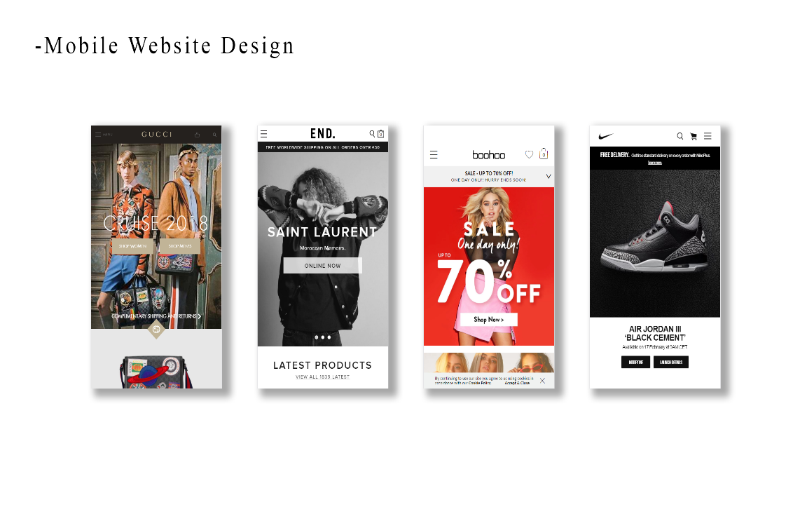

Above are the mobile versions of the sites, they very clearly try to keep the viewport similar to the desktop version. They generally move the Nav bar into a drop down ‘burger menu’, and then have additional links as you scroll down the page.